**For developing a university website first I have drawn sketches and its wireframe. Here are the sketches of my chosen university (University of Toronto).**

**Sketches:**

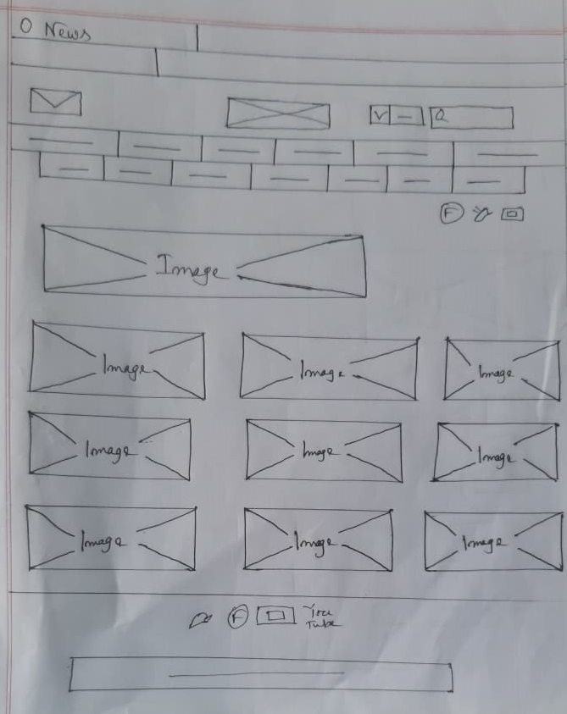

Figure: Sketches for news page

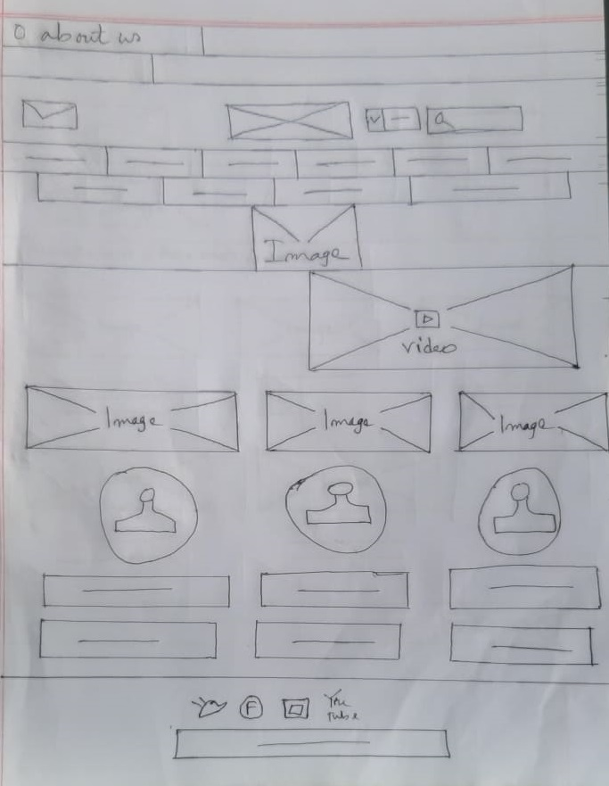

Figure: About page

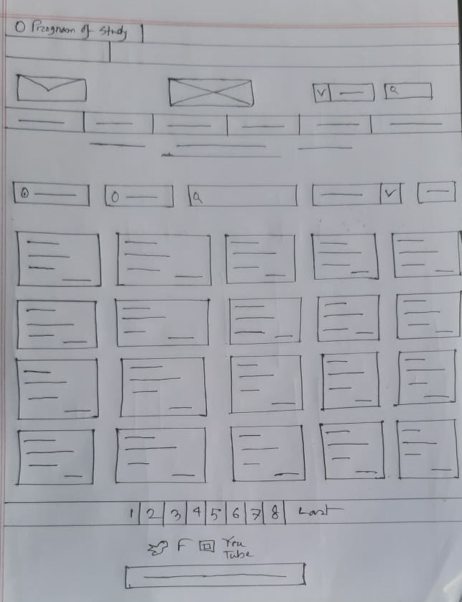

Figure: Courses offered in U of T

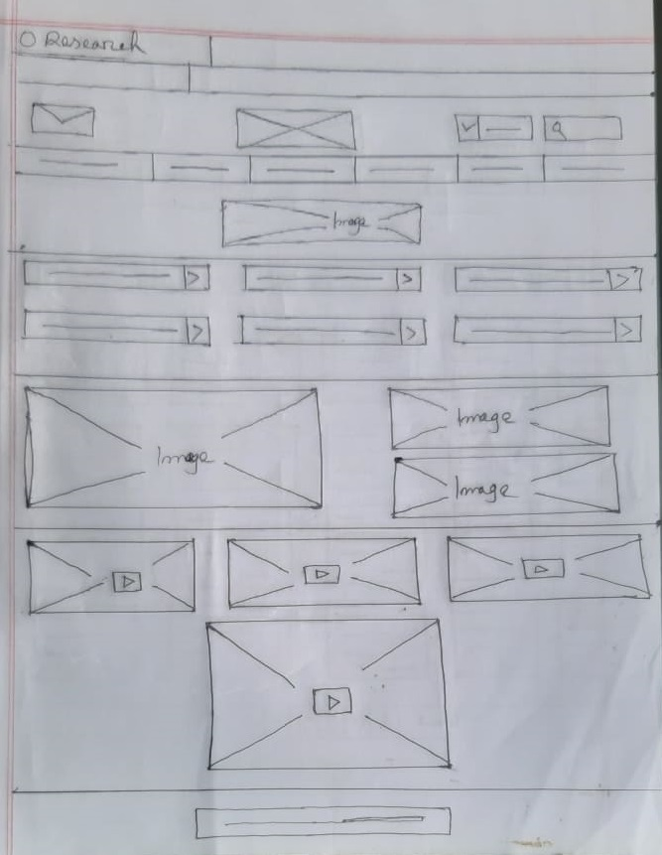

Figure: Sketches for Research page

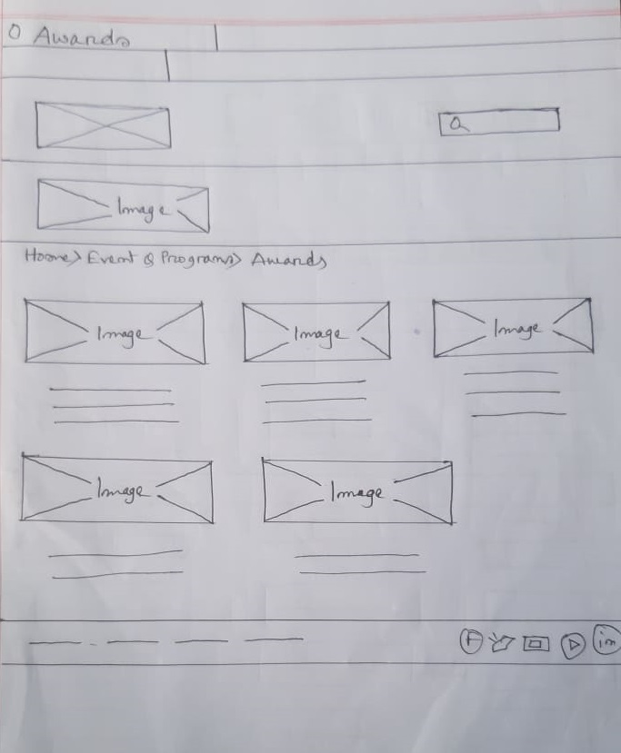

Figure: success stories of previous students

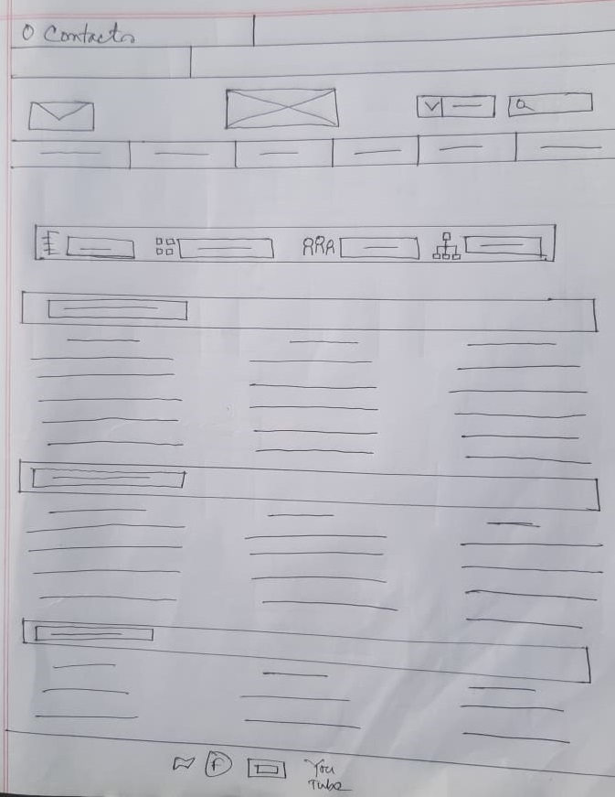

Figure: Contact information

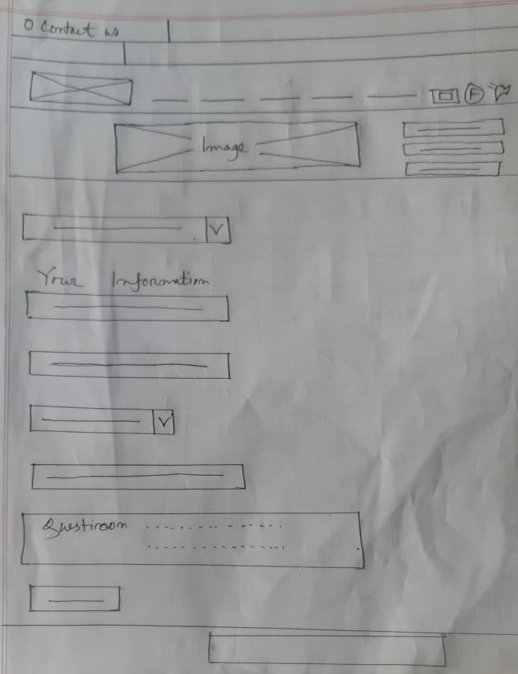

Figure: Deal with enquiries

Then I made the wireframe of the landing page that will be shown look like these in actual website.

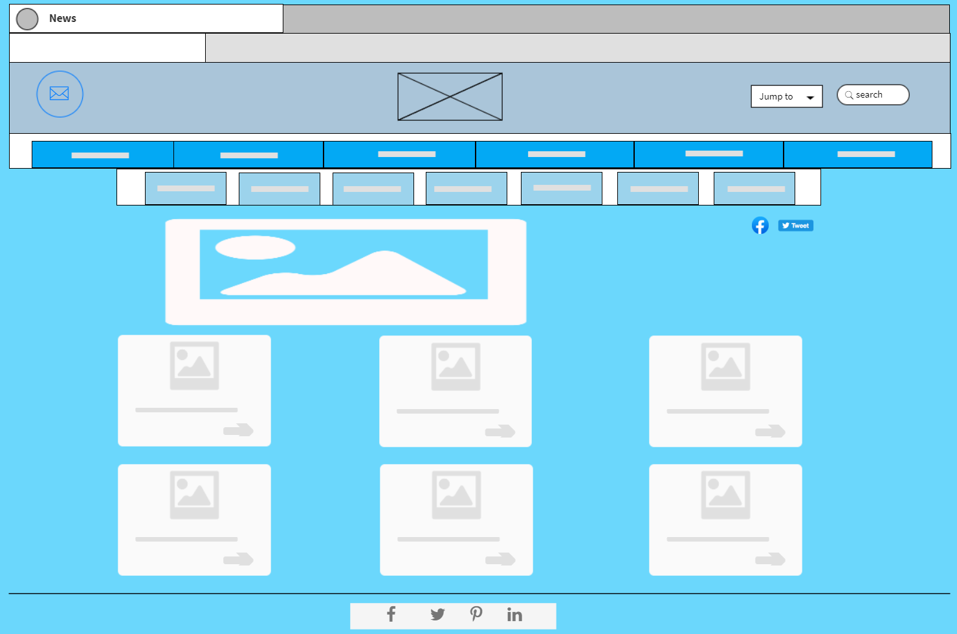

Figure: News page

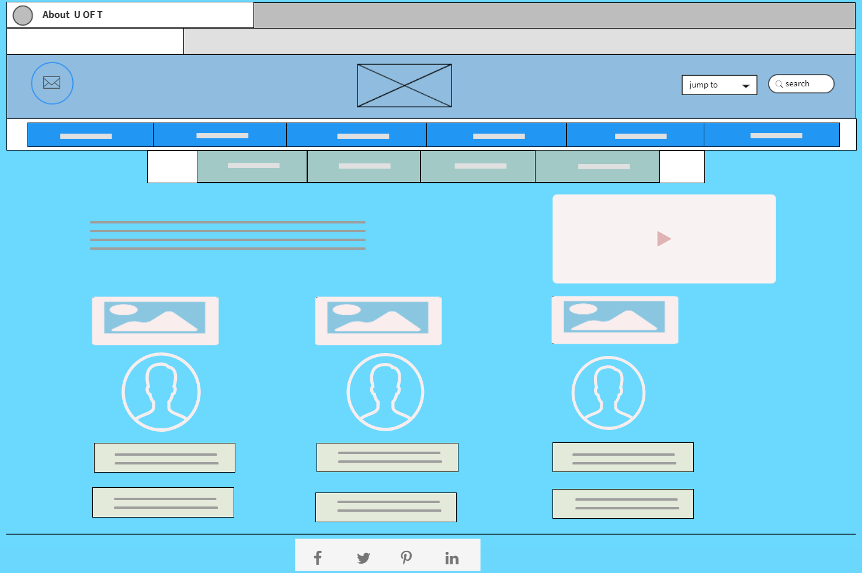

Figure: About page

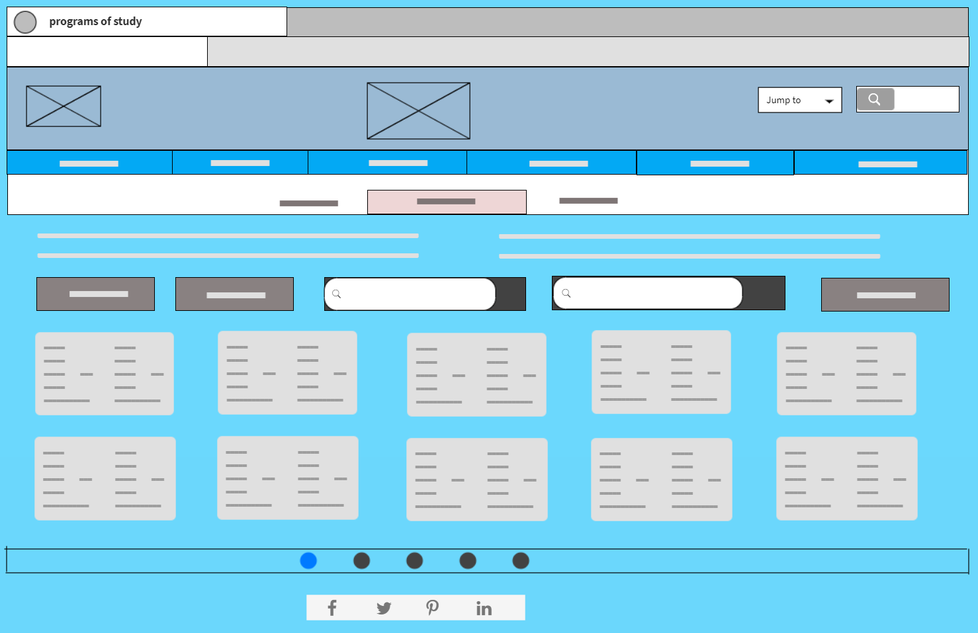

Figure: Courses offered for website

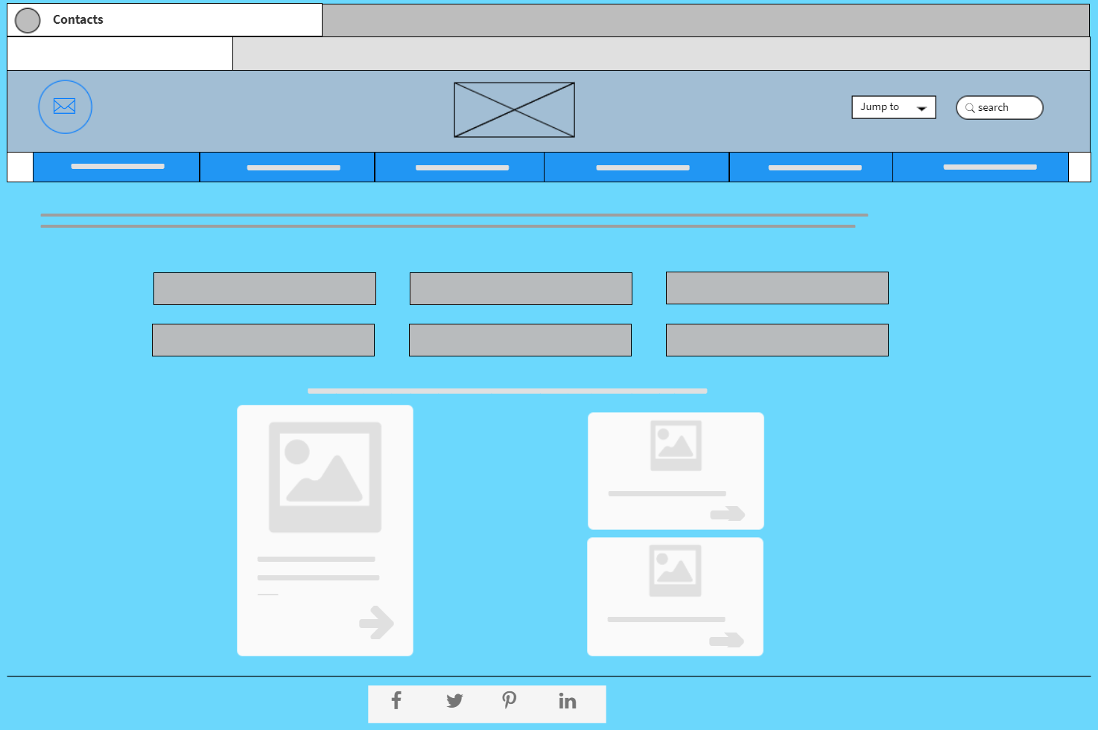

Figure: Research page

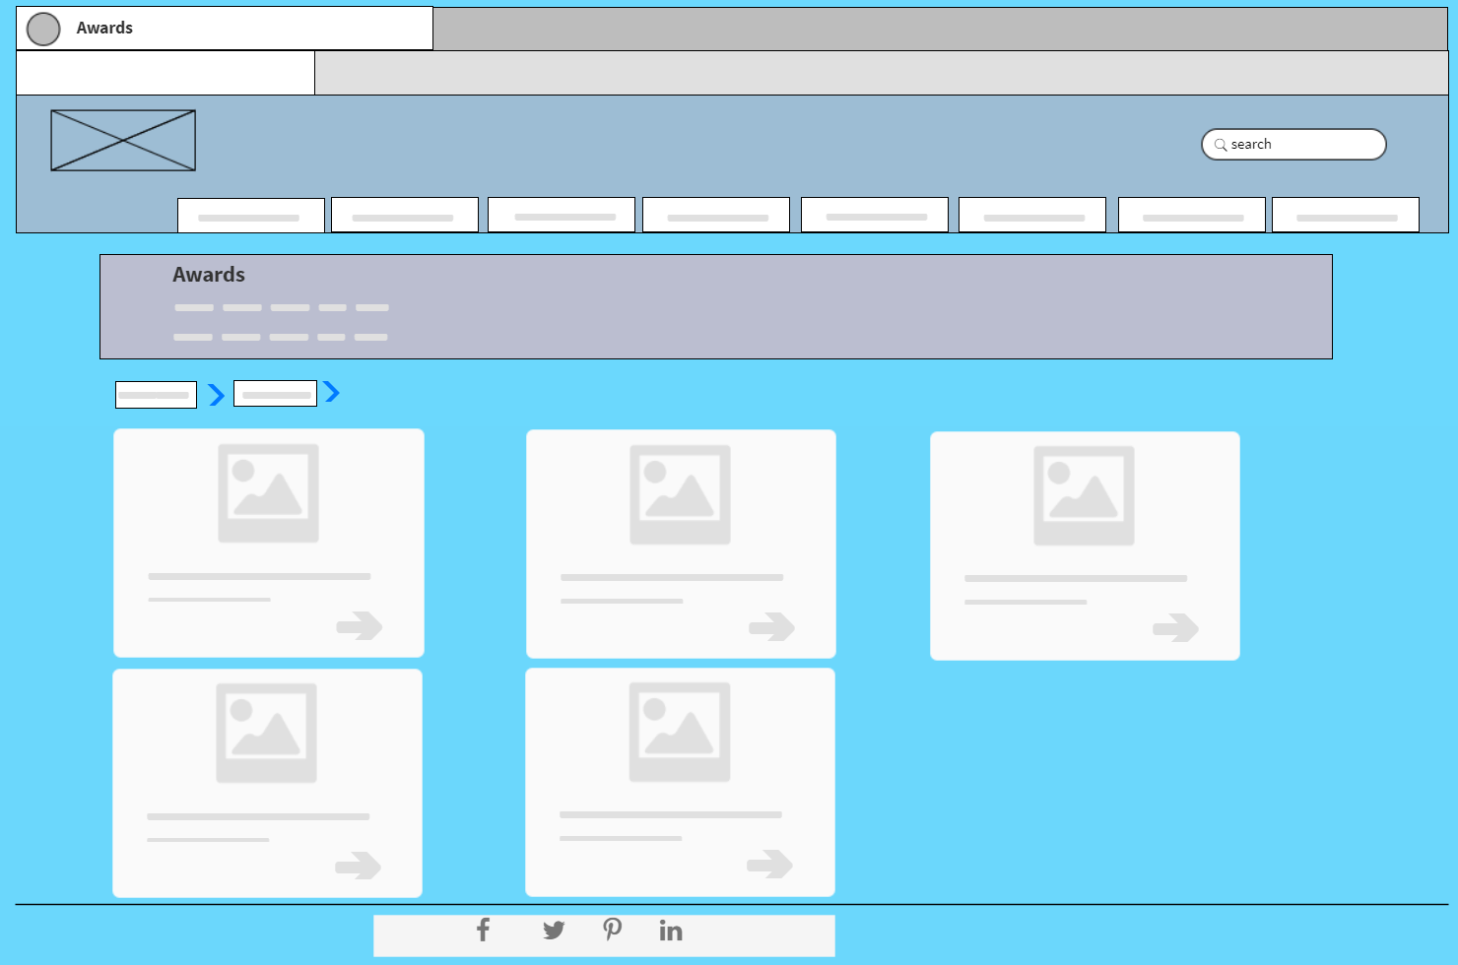

Figure: Success story of previous students

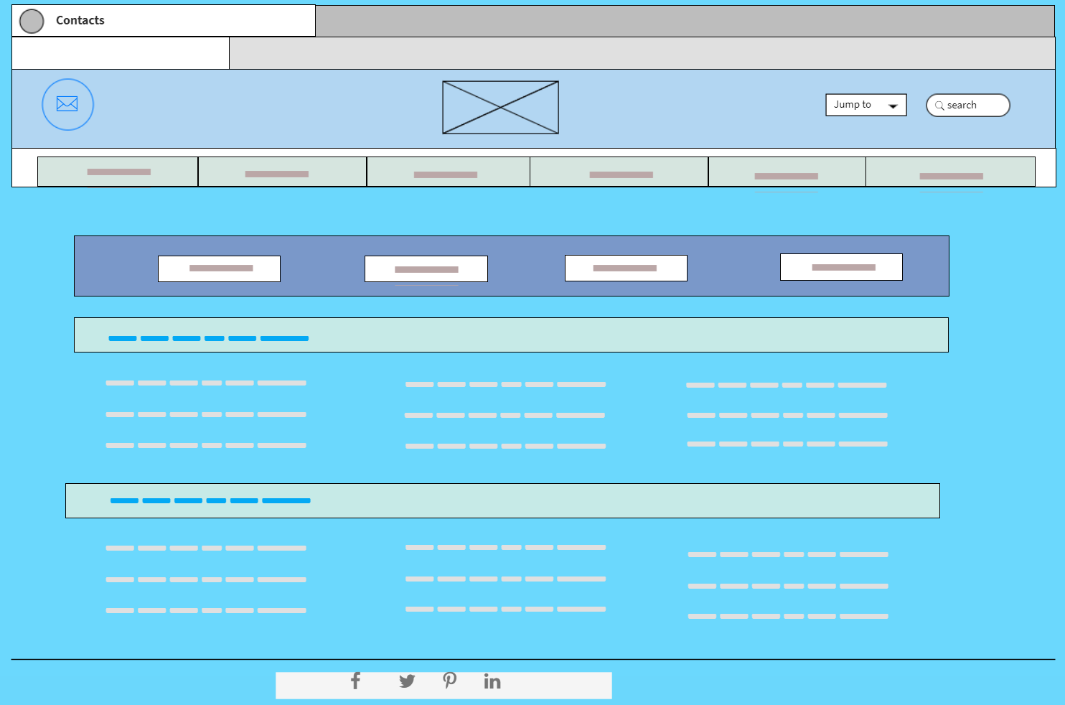

Figure: Contact information

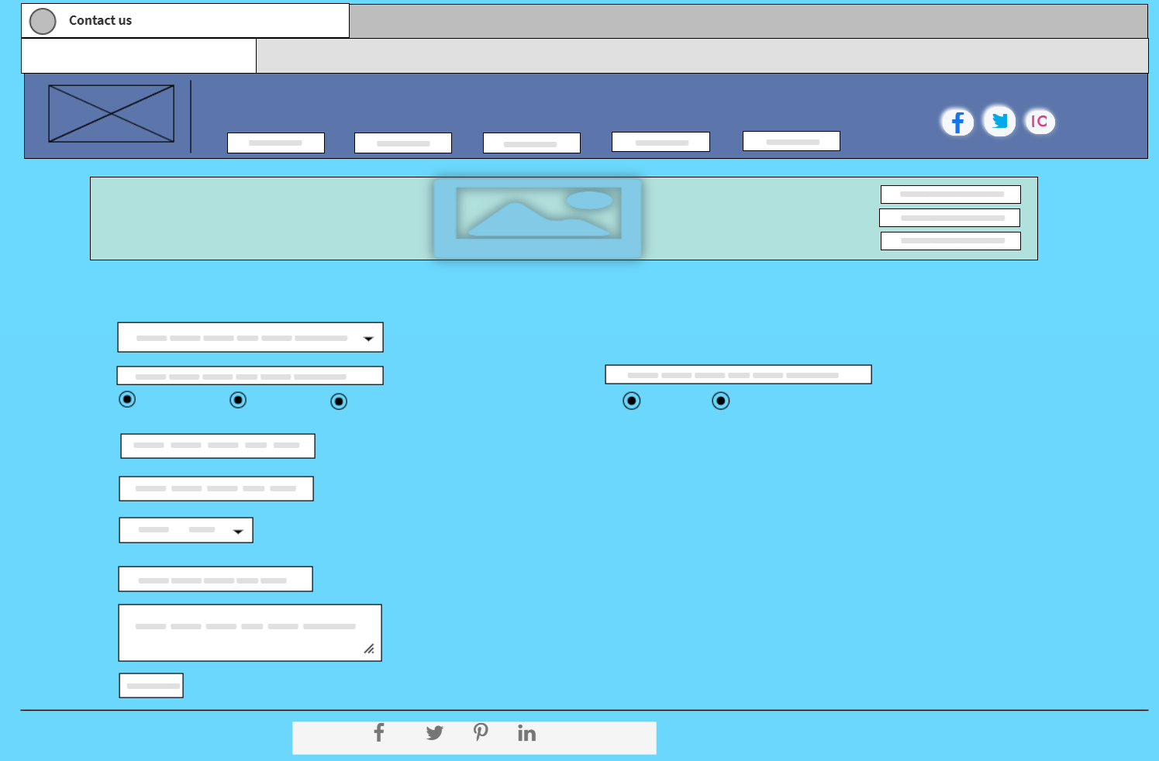

Figure: Deal with enquiries